**EX NO: 11C**

**DATE:**

**REMOTE PROCEDURE CALL FOR LIST OPERATIONS- XMLRPC**

**AIM:**

To Implement an XML RPC code for the following functions, a. No of items in a list

b. Smallest element in a list

c. Largest element in the list

d. Converting a list to a set.

**Program**

**Server Side:**

from xmlrpc.server import SimpleXMLRPCServer

def list_length(a):

return len(a)

def list_maximum(a):

return max(a)

def list_minimum(a):

return min(a)

def list_to_set(a):

f=list(set(a))

return f

def list_concate(a,b):

return a+b

server = SimpleXMLRPCServer(("localhost", 8000)) print("Listening on port 8000...")

server.register_function(list_length,"list_length")

server.register_function(list_maximum, "list_maximum") server.register_function(list_minimum, "list_minimum")

server.register_function(list_to_set, "list_to_set") server.register_function(list_concate, "list_concate") server.serve_forever()

**Client Side:**

import xmlrpc.client

proxy= xmlrpc.client.ServerProxy('http://localhost:8000/') while True:

print("PRESS 1-->STRAT || 2--> STOP ")

c=int(input("ENTER YOUR CHOICE"))

a=[]

b=[]

if c==1:

print("ENTER THE ELEMENTS TO ADD FIRST LIST") print("PRESS -1 TO EXIT THIS LIST")

while True:

d=int(input("--->"))

if d==-1:

break

a.append(d)

print("ENTER THE ELEMENTS TO ADD SECOND LIST") print("PRESS -2 TO EXIT THIS LIST")

while True:

e=int(input("--->"))

if e==-2:

break

b.append(e)

if c==2:

break

print(a)

print(b)

print("list_length",proxy.list_length(a))

print("list_maximum",proxy.list_maximum(a)) print("list_minimum",proxy.list_minimum(a)) print("list_to_set",proxy.list_to_set(a))

print("list_concate",proxy.list_concate(a,b))

**Output**

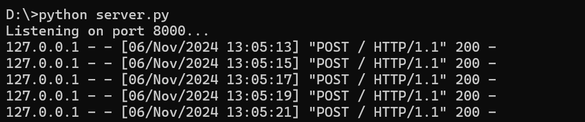

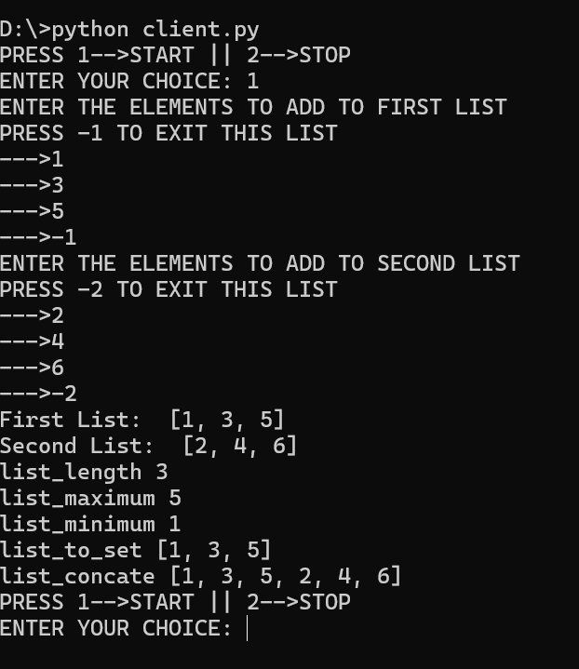

**Result:**

Hence the following list of operations have been Implemented by an XML RPC code for the following functions

a. No of items in a list

b. Smallest element in a list

c. Largest element in the list

d. Converting a list to a set.